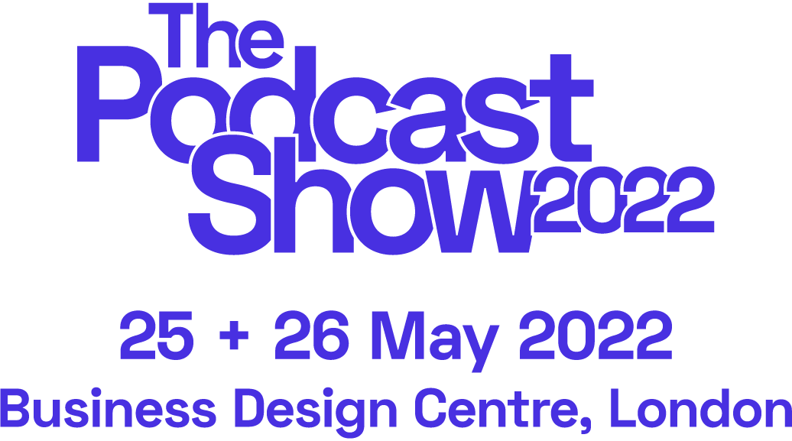

**SOCIAL POSTS**

**SUGGESTED COPY**

*We're delighted to be part of @PodcastShowLDN - coming to London in May. First release delegate day passes are on sale now - book yours now and we'll see you there!* [*https://www.thepodcastshowlondon.com/*](https://www.thepodcastshowlondon.com/) *#PodShowLDN*

***Socials***

Instagram: [@PodcastShowLDN](https://www.instagram.com/podcastshowldn/)

Facebook: [@PodcastShowLDN](https://www.facebook.com/PodcastShowLDN)

Twitter: [@PodcastShowLDN](https://twitter.com/podcastshowldn)

LinkedIn: [@PodcastShowLDN](https://www.linkedin.com/company/the-podcast-show/)